The HRM/ EMPLOYEE MANAGEMENT System is modeled in terms of objects and classes and their interaction with each other, explanation of the proposed system is done as well as structure of the Entity Relationship Diagram (ERD), Class Diagram, Data Flow Diagram (DFD), Screen Layout, Code Sign Test and Design Tools have been given to show detailed data modeling of the system. Further, the use cases which define set of interactions between external users and the system under consideration or development have also been given to show detailed data modeling of the system.

## 5.2 UML Diagram

The Unified Modeling Language (UML) is a general-purpose modeling language that includes a standardized graphical notation used to create model of a system, referred to as a UML model. The UML as used here in the system design will: -

* Showcase the functionality of the system from the user’s point of view
* Include use case diagrams
* Showcase the structure and sub-structure of the system using objects, attributes, operations, associations, and includes class diagrams.

### 5.2.1 Use case analysis

A use case defines a goal-oriented set of interactions between external users and the system under consideration or development. Thus, a Use Case Scenario is a description that illustrates, step by step, how a user is intending to use a system, essentially capturing the system behavior from the user's point of view.

**Use case diagrams:**

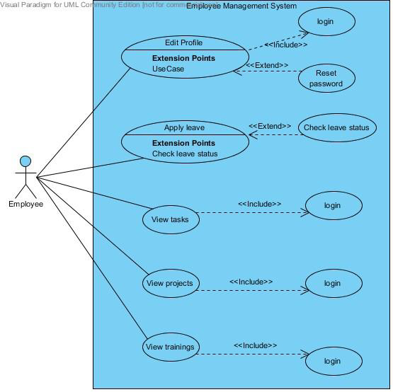

Figure 5.0 Employee Use Case

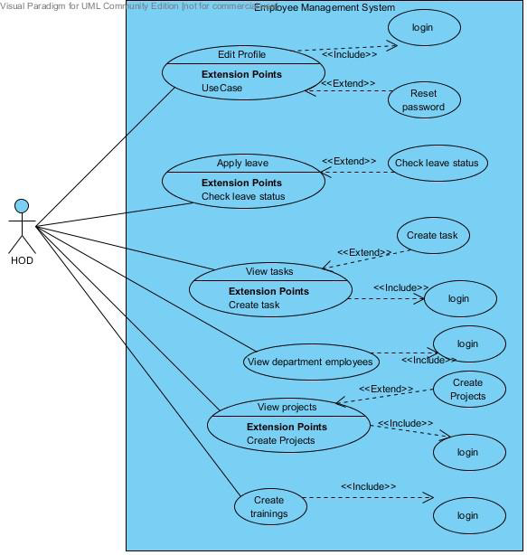

Figure 5.1 Head of Department Use case



Figure 5.2 Human Resource Use Case 

Figure 5.3 Admin Use Case

Class Diagram

Class diagram is a picture of the classes, their fields, methods, and connections between the classes that interact or inherit from each other. In the below class diagram, the Employee and Admin classes inherit from the User class. The employee class is also parent class to Human Resource class, Head of Department class and Ordinary employee class. An ordinary employee may include supply chain and procurement officers, accountants and all other employees that do not interact with the system with many privileges. These employees carry out the same operations.

Figure 5.4 Employee Management System Class diagram

**User**

User ID

Username

Password

first Name

last Name

Users’ role

login

Update details

**Admin**

registration ()

search ()

activity log ()

add user ()

send email ()

**Employee**

Department

Name

Pfno

Email

Location

Nationality

Home Area

Duties

AcademicDetails

EmploymentHistory

nextofKin&Dependants

login

leaveapply()

leavestatus()

updatedetails()

projects()

trainings()

techskills()

viewemails()

=

**Human Resource**

search()

generatereports()

leave()

sendemail()

**Head of Department**

search ()

assigntasks ()

viewtrainings ()

### 5.2.3 Entity Relationship Diagram (ERD)

The ERD is a chart that visually represents the relationship between database entities. It models an organization’s data storage requirements with three main components: -

1. Entities –Are objects or concepts that represent important data. They are typically nouns e.g., customer, supervisor, location, promotion, places, items, events.
2. Attributes – Represents properties of descriptive qualities of an entity, also known as data events.
3. Relationship – Represents the link between different entities and describes the relations between the entities

ERD shows entities in database and relationships between tables within that database and helps focus on how the database actually works.

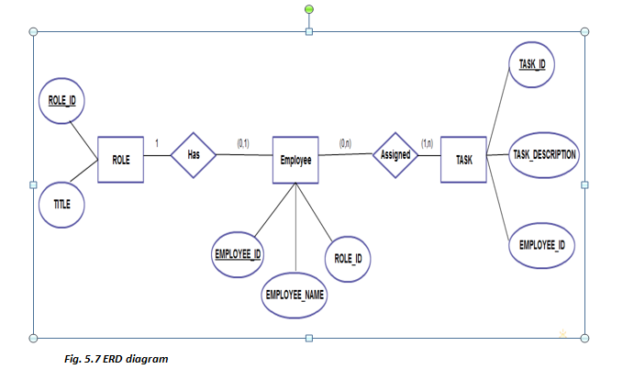

Figure 5.7 ERD diagram

Design Tools

This part account of the technologies that could be used in the development of the system.

### 5.5.1 Front End Technologies

Front end-is a term used to characterize program interfaces and services relative to the initial user of these interface and services. It usually refers to the client side of an application. A frontend application is one that users interact with directly. Turban et al (2008, p45) defines front end as the portion of an e-seller’s portal, electronic catalogues, a shopping cart, a search engine and a payment gateway.

**HTML**

HyperText Markup Language (HTML) is a computer language devised to allow website creation. These websites can then be viewed by anyone else connected to the Internet. It is relatively easy to learn, with the basics being accessible to most people in one sitting; and quite powerful in what it allows you to create.

Having the basic knowledge of HTML will help make or develop websites and will also prove to be handy especially for editing and modifying web pages. Furthermore, it has some low-cost benefits because of its many free online tutorials and advice support which is vital for website development.

**JavaScript**

JavaScript is a scripting language that is browser based and was developed by Netscape to enable web masters/authors to add interactivity and enhances behaviour of web pages. Some of the dynamic behaviour that can be generated by JavaScript is validating form, performing specific actions e.g., after a mouse click, adding timestamps etc. JavaScript is an open language and anyone can use it. It also shares many of the features and structures of the Java programming language, though it is not really related to Java. It was developed independently.

**CSS**

CSS is a Cascading Style Sheet language used to describe presentation and layout of documents written in HTML. CSS is used to enable separation of document content from document presentation. This refers to the separation of document presentation aspects such as colours, layouts and fonts from the actual documents content. CSS help us achieve layout design and control much easier.

### 5.5.2 Back End Technologies

The back-end or the (server-side) is basically how the site works, updates and changes. It refers to everything the user can’t see in the browser, like databases and servers.

**PHP**

PHP is an abbreviation for, Hypertext Pre-processor. Is a widely-used open source general-purpose/programming/scripting language that is especially suited for web development and can be embedded into HTML. PHP is an open-source code (free software). It is used for creating dynamic web pages that interact with the user and can include functionalities such as; getting user input, manipulation of the input and storage of data in secure and suitable DBMS. PHP is also easy to integrate with web pages.

**MySQL**

MySQL stands for My Structured Query Language. It is the world’s most popular open-source relational DBMS. MySQL it is the standard language for relational database management systems. It is non-proprietary, easily extensible and platform independent and its statements are used to perform tasks such as update data on a database, or retrieve data from a database. Its downside is that it lacks a graphical user interface; therefore, you need to know how the database works to make the most efficient use of it.